An unhurried weekend
  - Two days by the coast
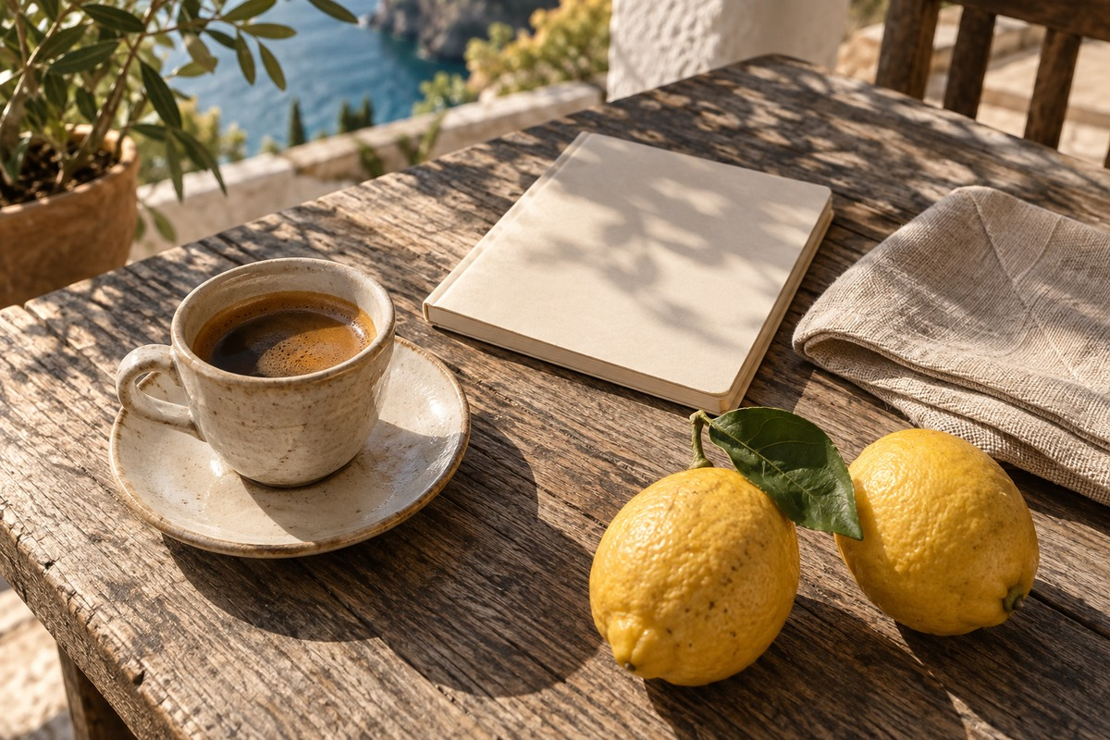
A quiet table, a notebook and time to look around.

The plan
Leave room between destinations. Begin with coffee, walk along the water and return before the afternoon light disappears.
Day | Morning | Afternoon
Friday | Arrive and settle in | Harbor walk
Saturday | Market and coffee | Coastal path
Sunday | Slow breakfast | Pack and return

Details worth keeping
The itinerary is a suggestion, not a timetable. Keep the afternoon free if the weather is good.

Packing list
- Notebook and a pen
- Water bottle and a light jacket
- A camera, with room for more pictures

Shared notes
한국어 문서 · 日本語の文書 · العربية · Grüße aus Berlin
Reference: 001234567890123456789
Prepared as an original BlurMe example. All names and amounts are fictional.
More information: BlurMe

Original sample footnote.

